C O N F I D E N T I A L

Healing Hands Healing Hearts L.L.C.

Business Plan

### Prepared May 2021

#### Contact Information

Mahamadi Sawadago RN BSN

[msawadogo@healinghh.co](mailto:msawadogo@healinghh.co)

4132 Lancaster Circle

Waldorf, MD 20603

m [www.healinghh.com](http://www.healinghh.com/) 202-290-5123



#### Healing Hands Healing Hearts L.L.C. i



Table of Contents

Executive Summary 1

Who We Are 1

What We Offer 1

Who We Serve 2

Financial Summary 2

Company 3

Company Overview 3

Management Team 3

Products and Services 6

Products and Services 6

Service Area 6

Target Market 8

Market Overview 8

Market Needs 8

Strategy and Implementation 10

Marketing Plan 10

Financial Plan 11

Revenue Forecast 11

Personnel Plan 12

Budget 14

Profit and Loss Statement 15

Appendix 17

Revenue Forecast 17

Personnel Plan 18

Budget 19

Profit and Loss Statement 21

**CONFIDENTIAL - DO NOT DISSEMINATE**. This business plan contains confidential, trade-secret information and is shared only with the understanding that you will not share its contents or ideas with third parties without the express written consent of the plan author.

#### Healing Hands Healing Hearts L.L.C. 1



# Executive Summary

## Who We Are

Healing Hands Healing Hearts LLC is a team of health care professionals dedicated to providing communities with outstanding patient care. We apply a comprehensive approach to coordinating resources and working in partnership with our patients as well as their family and doctors. Through community service we maintain positive relationships by participating in health fairs, daily activities and other community events. We understand the importance of demonstrating our commitment to the wellness of our local communities we serve.

Healing Hands Healing Hearts LLC adheres to a strict hiring process of only selecting extremely well qualified clinicians. All employees are experienced health care workers, some possess prior home care experience. After hiring, clinicians participate in a structured orientation program which includes demonstration of competency in their specialty area. These assessed skills are monitored in regular intervals and monthly in-services are performed to ensure clinicians remain current on updated practices. Interdisciplinary case management meetings are also conducted as part of our effort to offer the most thorough coordination of care.

Our marketing team's primary goal is to strengthen relationships with facility personnel to simplify discharge procedures, meet request and streamline referrals for our patients. The referral process begins with the marketing team experts who expediently and efficiently address all matters to the patient's and discharge planners satisfaction.

In addition to having an impeccable, experienced marketing team and clinicians, the administrative staff exemplifies professionalism and customer service. Being the pulse of the company, they ensure clinicians are notified and dispatched to assignments in a timely manner, as well as providing the utmost satisfaction for our clients during the admissions process. Healing Hands Healing Hearts LLC maintains partnerships with many small businesses and offer the latest in technologies that will improve access to care and the well being of the communities we serve.

## What We Offer

At Healing Hands Healing Hearts LLC we offer our patient's an unforgettable experience. Providing qualified clinicians in addition to excellent marketing and administrative staff to assure all of our patient's needs and concerns are addressed.

**CONFIDENTIAL - DO NOT DISSEMINATE**. This business plan contains confidential, trade-secret information and is shared only with the understanding that you will not share its contents or ideas with third parties without the express written consent of the plan author.

#### Healing Hands Healing Hearts L.L.C. 2



## Who We Serve

Patients are our priority. Each team member is focused on the patient receiving the best care. We also assist healthcare providers by ensuring that their patients are well cared for in all aspects of their health and home environment. Healing Hands Healing Hearts LLC also serves the community by patronizing and partnering with many local businesses. We also specialize in providing wound care for all wound types.

## Financial Summary

###### Financial Highlights

Healing Hands Healing Hearts LLC may endure a small financial loss in the first year in business, as our customer base grows, so will our profit margin. This increase will allow us to improve a variety of offers to our patients and employees. As our profit margin grows, we hope to enhance the benefits to patients and employees and improve overall satisfaction with our company.

###### Revenue by Year

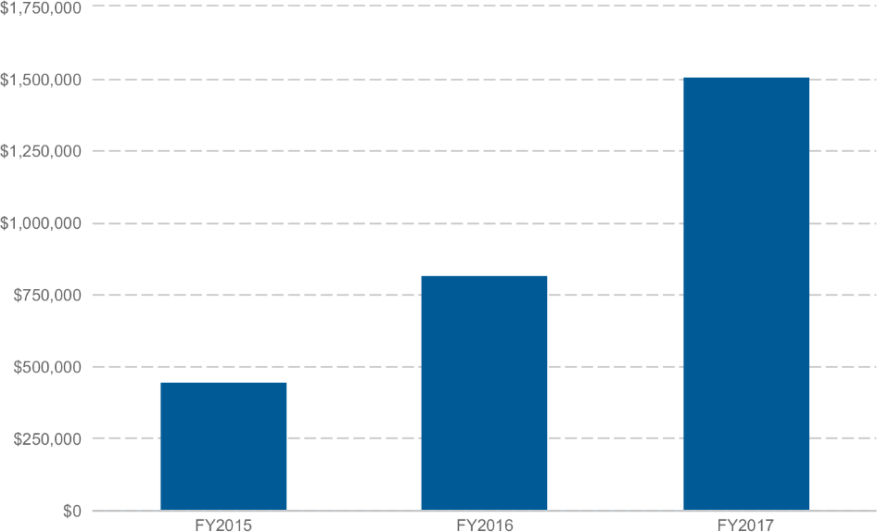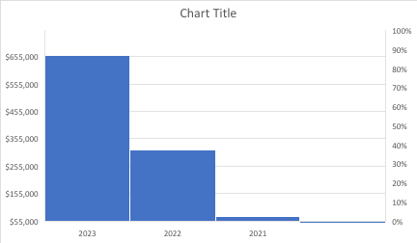

**CONFIDENTIAL - DO NOT DISSEMINATE**. This business plan contains confidential, trade-secret information and is shared only with the understanding that you will not share its contents or ideas with third parties without the express written consent of the plan author.

#### Healing Hands Healing Hearts L.L.C. 3



# Company

## Company Overview

Healing Hands Healing Hearts LLC is a new company with the following objectives:

1. Improving productivity and efficiency at all levels in the organization.
2. Establishing relationships that promote an improved working environment between all staff and clients.
3. Delivering quality services that meet the requirements of regulatory agencies through an effective management program.
4. Fulfilling the needs of clients by implementing programs and services through skilled professionals who are committed to excellence.

## Management Team

Mahamadi Sawadago, RN BSN Founder and Director of Nursing

Mahamadi Sawadogo is the founder of Healing Hands Healing Hearts L.L.C, a home health agency that aims to treat patients from post operative to chronic wounds.

Before establishing is agency, Mahamadi worked in home health for many years were with the coordination of doctors helped healed thousands of wounds . He has been in the healthcare field for over 15 years.

Mahamadi Sawadogo has worked in all spectrum of healthcare including being a home health aide, a certified nursing assistant , a licensed practical nurse.

As a licensed practical nurse is worked for Sunrise Senior living starting as a wellness nurse then got promoted to Resident care coordinator, while also working in home health treating patients wounds , and managing their disease process and symptoms.

Mahamadi, love in nursing grew more and he went back and graduated from Stratford University with his Bachelors in nursing , then took a wound care certification course to enhance is knowledge in treating all wounds .

#### Healing Hands Healing Hearts L.L.C. 4

**Below is a listing of my essential job functions and responsibilities:**

1. Provide direct supervision to LPNs
2. Provide guidance and counseling on clinical aspects of patient care
3. Provide direct supervision to nursing staff
4. Provide resources for all clinicians
5. Conduct weekly clinical meetings
6. Conduct daily meetings with office/support staff (to include census, trends, issues and budget.)
7. Provide clinical orientation and preceptorship with new nursing staff
8. Evaluate initial and annual performance of clinical staff
9. Counsel clinicians and office staff and initiate disciplinary actions if applicable
10. Conduct clinical competencies at pre-determined intervals
11. Review charts for accuracy in documentation
12. Review charts for billing purposes
13. Provide OASIS training for new staff
14. Review OASIS data and send to Medicare
15. Call Primary care doctors and coordinate services for patients
16. Maintain professional relationship with clinical staff, office staff, administration, marketing staff, case managers and other referral sources.
17. Participate and organize community events to promote organizational activities and presence in the community
18. Developed and implemented inservices and continuing education needs of organization
19. Maintain up to date on current trends and changes in healthcare and share relevant data with organization
20. Promote organizational presence in the community
21. Assist DON in other areas as needed

#### Healing Hands Healing Hearts L.L.C. 6



# Products and Services

## Products and Services

Healing Hands Healing Hearts LLC provides highly skilled and qualified professionals delivering homecare services without regards to race, religion, age, gender, sexual orientation, disability, ase or place of national c*origin.

###### S* ervices provided

* Personal Caregivers
* Home Health Aides
* Certified Nursing Assistants
* Licensed Practical Nurses
* Registered Nurses
* Personal Care Services
* Private Duty Companionship

## Service Area

Healing Hands Healing Hearts LLC renders home care services in the following Maryland

localities, based on clinician ability:

* Charles County
* Prince Georges County

**CONFIDENTIAL - DO NOT DISSEMINATE**. This business plan contains confidential, trade-secret information and is shared only with the understanding that you will not share its contents or ideas with third parties without the express written consent of the plan author.

#### Healing Hands Healing Hearts L.L.C. 7



**CONFIDENTIAL - DO NOT DISSEMINATE**. This business plan contains confidential, trade-secret information and is shared only with the understanding that you will not share its contents or ideas with third parties without the express written consent of the plan author.

#### Healing Hands Healing Hearts L.L.C. 8



# Target Market

## Market Overview

Statistics:

The average daily cost per patient for an inpatient hospital stay in Maryland is $1759. (*Complete home care services average less than $200/day).*

Maryland comprises 2% of total healthcare expenses in the USA.

###### The health spending per capita in Maryland is $8602

7.9% of the total Maryland population consists of uninsured elderly persons. (*Many programs are available to assist this population. Home care nurses and social workers help to coordinate needs and community resources. We also offer many services that can benefit the uninsured).*

Based on a community needs assessment that was done in 2009 in our target market area, there were over 35,000 avoidable hospitalizations. Of these hospitalizations Congestive Heart Failure (CHF) accounted for 19,607, Diabetes = 10,474, Chronic Obstructive Pulmonary Disease = 11,000 and 2711 were for High Blood Pressure. These are the same patients that can benefit from the services home health can provide. Studies have shown that patients are at the greatest risk for re-hospitalization in the first 72 hours after discharge. *Our skilled nurses offer intense education and vital sign management (including blood sugar monitoring), medication teaching and reconciliation with the primary care provider (PCP), emphasize on proper diet aligned with disease process, energy conservation techniques and monitoring of fluid status. These are examples of some of the few ways nurses can work with patients to keep them out of the hospital and independently at home. As part of a local survey (located in our target market area) 31% of respondents felt that home health could*

##### improve their overall care.

*[https://www.census.gov/q](http://www.census.gov/quickfacts/fact/table/charlescountymaryland%2CUS/PST045219)u*[*ickfacts/fact/table/charlescountymaryland,US/PST045219*](http://www.census.gov/quickfacts/fact/table/charlescountymaryland%2CUS/PST045219) *Adult population 65 years or older is 13% of 166,810 = 21, 685This is based off 2019 census stats that 13% of county is adults Estimated number of patients with chronic wounds: 7099*

**CONFIDENTIAL - DO NOT DISSEMINATE**. This business plan contains confidential, trade-secret information and is shared only with the understanding that you will not share its contents or ideas with third parties without the express written consent of the plan author.

#### Healing Hands Healing Hearts L.L.C. 9



**CONFIDENTIAL - DO NOT DISSEMINATE**. This business plan contains confidential, trade-secret information and is shared only with the understanding that you will not share its contents or ideas with third parties without the express written consent of the plan author.

#### Healing Hands Healing Hearts L.L.C. 10



# Strategy and Implementation

## Marketing Plan

###### Overview

Healing Hands Healing Hearts' marketing strategy is simply to provide the best care for our patients and the best services for our clients. We take pride in providing a well qualified team with extensive knowledge in their field of practice. Through networking we will enhance our business as well as build positive relationships with our community. Our expertise and professionalism will stand on it's on. Our goal is to advertise online and in local newspapers, arrange quarterly promotional meetings with local hospitals and medical facility administrators and also provide brochures at local community events.

###### Positioning

We are Healing Hands Healing Hearts and our mission is to provide an impeccable service to our patients and clients. Our goal is to be recognized for our professionalism, dependability, confidentiality and qualifications. It is our responsibility to make sure our patients are satisfied and receives the best care we have to offer.

###### Pricing

Healing Hands Healing Hearts will be priced competitively with what current market trends, competing with similar types of services in the area.

###### Promotion

Our marketing team will be responsible for orchestrating a quarterly open house for our potential clients. We will also provide a promotional discount for clients who refer our company to a patient that renders our services.

###### Distribution

Healing Hands Healing Hearts will be offering services directly to our clients. Patients will also be able to contact us for services at their home. Our marketing team will be responsible for delivering brochures and all

other correspondence to our clients and patients via email, personal or postal delivery. We will also have a broadcast on our webpage for an upcoming open house and promotional events for that month.

**CONFIDENTIAL - DO NOT DISSEMINATE**. This business plan contains confidential, trade-secret information and is shared only with the understanding that you will not share its contents or ideas with third parties without the express written consent of the plan author.

#### Healing Hands Healing Hearts L.L.C.



**CONFIDENTIAL - DO NOT DISSEMINATE**. This business plan contains confidential, trade-secret information and is shared only with the understanding that you will not share its contents or ideas with third parties without the express written consent of the plan author.

#### Healing Hands Healing Hearts L.L.C. 12



**CONFIDENTIAL - DO NOT DISSEMINATE**. This business plan contains confidential, trade-secret information and is shared only with the understanding that you will not share its contents or ideas with third parties without the express written consent of the plan author.

#### Healing Hands Healing Hearts L.L.C. 13



#### Healing Hands Healing Hearts L.L.C. 14

#### Healing Hands Healing Hearts L.L.C. 15

###### Startup Costs

Total start-up requirements include marketing and promotional tools, employees salary, rent and related expenses. The start-up costs are to be financed partially by the direct owner investment and long-term loan financing.

Marketing expenses will be higher in the first year to announce the opening of the company and

will decrease after that. Most expenses will show small increases each year as the business will remain in the same location over the first three years.

**Financial Plan**

**Revenue Forecast**

**Revenue FY2021 FY2022 FY2023**

**Revenue $400,000 $800,000 $1,500,000**

**Direct Cost $160,000 $350,000 $ 550,000**

**Gross Margin $240,000 $450,000 $ 950,000**

**Gross Margin Percentage 40% 44% 55%**

**Breakdown of Revenue** **FY2021 FY202 FY2023**

Personal Pay Clients $ 40,000 $160,000 $320,000

Private Insurance $160,000 $256,000 $384,000

Medicare/Medicaid $200,000 $384,000 $796,000

**Total Revenue** $400,000 $800,000 $1,500,000

**Breakdown of Direct Cost FY2021 FY2022 FY2023**

Personal Pay Clients $20,000 $80,000 $120,000

Private Insurance $55,000 $110,000 $190,000

Medicare/Medicaid $85,000 $160,000 $240,000

**Total Direct Cost $160,000 $350,000 $550,000**

About the Revenue Forecast: The revenue forecast demonstrates Healing Hands Healing Hearts growing over the next few years. We expect through our promotions, advertising and good old fashion "word of mouth" our business will soar. We have predicted that our ties to the community will bring us more clients as well as our competitive prices. Our mission is to provide affordable prices that will beat out competition and drive our business to become a great success

---------------------------------------------------------------------------------------------------------------------

**CONFIDENTIAL - DO NOT DISSEMINATE**. This business plan contains confidential, trade-secret information and is shared only with the understanding that you will not share its contents or ideas with third parties without the express written consent of the plan author.

**Personnel Plan**

**Role FY2021 FY2022 FY2023**

Administrator $10,000 $ 50,000 $150,000

Director of Nursing n/a $ 75,000 $250,000

Aide $25,000 $ 70,000 $ 70,000

Nurse $10,000 $ 30,000 $ 90,000

Physical Therapist $15,000 $ 60,000 $100,000

**Totals $60,000 $285.000 $660,000**

The personnel plan will be as follows: One Administrator to oversee all Administrative duties, daily operations and budgets as well as ensuring all Maryland laws and agency policies are followed.

One Director of Nursing to develop and implement clinician policy and procedures to prevent incidents at facilities and patient's residence, also overseeing the hiring and continued employment of clinicians. Will ensure there is adequate staff for all assignments. Assessing and verifying that all clinician's skills remain current. Maintaining an open line of communication with patients and clients. Will be the point of contact for incidents that may occur with referral sources or a patient's residence.

One supervising Physical Therapist to provide health maintenance, rehabilitation, wellness and fitness. To determine diagnoses, prognosis, and plans of care, physical therapists perform evaluations, symphonizing the examination data and deciding whether the concerns to be addressed are within the scope of physical therapist practice.

One supervising Nurse to assess and plan nursing care for patients, monitor and administer medication and intravenous infusions, take patient's samples, pulse, temperature, blood pressure, record all assessments and provide emotional support for patients and family and other aspects related to patients’ condition.

A marketing team to handle promotional brochures, online and newspaper advertisements, arranging open house events as well as answering request and referrals for patients.

In our first year we will be hiring Home health aides, an administrative assistant and more clinicians as patient clientele expands

**CONFIDENTIAL - DO NOT DISSEMINATE**. This business plan contains confidential, trade-secret information and is shared only with the understanding that you will not share its contents or ideas with third parties without the express written consent of the plan author.

**Operating Expenses**

**Operating Expense FY2021 FY2022 FY2023**

Salary $220,000 $285,000 $399,000

Employee Related Expenses $25,000 $ 75,000 $108,750

Marketing & Promotions $ 5,000 $ 8,000 $ 16,000

Office Supplies/Equipment $ 2,500 $ 5,000 $ 20,000

Rent $ 8,000 $ 12,000 $ 15,000

Insurance $ 3,000 $ 5,000 $ 5,000

**Total Operating Expenses $263,500 $390.000 $578,750**

**About the Expenses:** Payroll is by far the largest expense the company incurs. Staff will need to be managed and hours regulated so that hours worked correlate to the amount of assignments we receive. Emphasis will be placed on minimizing expenses that do not help generate bottom line.

Marketing expenses will increase as the company promotes itself to gain more clients and establish itself in the community. Office supplies and equipment will increase as employee base is established. Equipment, including office furniture, telecommunication devices and laptops or iPads are added to inventory to continuously keep up with business and client needs. Most other expenses will show small increases each year as the business will remain in the same location over the first three years.

**Profit and Loss Statement**

**Revenue FY2021 FY2022 FY2023**

**Revenue $400,000 $800,000 $1,500,000**

**Direct Cost $160,000 $350,000 $ 550,000**

**Gross Margin $240,000 $450,000 $ 950,000**

**Gross Margin Percentage 40% 44% 55%**

**Operating Expenses**

Salary $220,000 $285,000 $399,000

Employee Related Expenses $25,000 $ 75,000 $108,750

Marketing & Promotions $ 5,000 $ 8,000 $ 16,000

Office Supplies/Equipment $ 2,500 $ 5,000 $ 20,000

Rent $ 8,000 $ 12,000 $ 15,000

Insurance $ 3,000 $ 5,000 $ 5,000

**Total Operating Expenses $263,500 $390.000 $578,750**

**Net Profit/Loss ($23,000) $60,000 $371,250**

**Percentage (8%) 14% 40%**

**Calculations for first year are based upon beginning company midyear. Full year revenue and expenses are calculated for future years.**

**Startup Costs**

Total start-up requirements include marketing and promotional tools, employees’ salary, rent and related expenses. The start-up costs are to be financed partially by the direct owner investment and long-term loan financing.

**CONFIDENTIAL - DO NOT DISSEMINATE**. This business plan contains confidential, trade-secret information and is shared only with the understanding that you will not share its contents or ideas with third parties without the express written consent of the plan author.